**The purpose of this project is to create an automated smoke test suite to add two items to the cart and place an order.**

Note: -

* The testng.xml contains the TestRunner class, which has @DataProvider and @Test methods to start the project execution.
* Cucumber feature files are used to write test steps and furnish test data. Additionally, excel sheet or properties file can be used to furnish the test data.
* Email address for registration is generated randomly.
* Screenshot is captured irrespective of the test run result.
* Currently, the verification/validation happens only at cart level and on the last page, but can be implemented whenever needed.
* Spark extent PDF reports and html reports are generated once the execution is complete.

Project Structure:  
- test.Runners package has the TestRunner class  
- resources/features folder has all the feature files  
- BaseActions class has all the actions  
- stepDefinition/PlaceOrder has all the step definition files  
- globalParameters.properties has all the configurable items  
- Report location: “test-output/SparkReport/Spark.html” and “/test output/PdfReport/ExtentPdf.pdf”

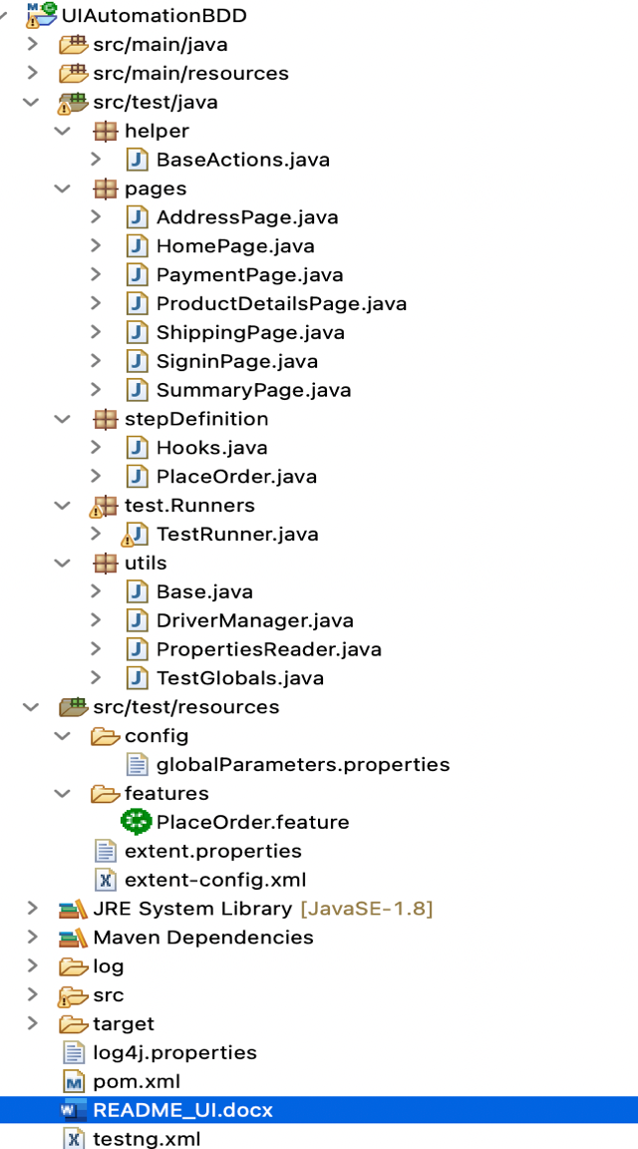

Feature file:  
Feature: Place an order for two items

Description: Smoke test to be able to add two items to the cart and place an order

@orderTwoProducts

Scenario: Place Order by selecting two different products from the sub category

Given User launches the website

When User selects the sub category from dresses tab

| Casual Dresses | Dresses |

And User adds product "Printed Dress" to the cart

And User clicks on Continue Shopping

And User selects the sub category from women tab

| Blouses | Women |

And User adds product "Blouse" to the cart

And User clicks on Proceed to checkout

And User verifies product quantiy in the cart

And User clicks on Proceed to checkout on Summary Page

And User enters email address inorder to create account

And User furnishes personal information to register

| Title | FirstName | LastName | Password | DoB | Company | Address | City | State | Zip | Mobile |

| Mr. | Abhi | Nagre | Abhi$499 | 19/1/2010| WooliesX | 2 Good St | Sydney | Alaska | 00000 | 0481019322 |

And User clicks on Proceed to checkout on Address Page

And User proceeds to checkout on Shipping Page by agreeing to the terms

And User selects payment option "Pay by bank wire"

And User confirms the order

Then User receives confirmation message "Your order on My Store is complete."

Project Execution:  
To run the project from maven, use the “mvn verify” command from the command line tool.

Below is the generated sample extent report:

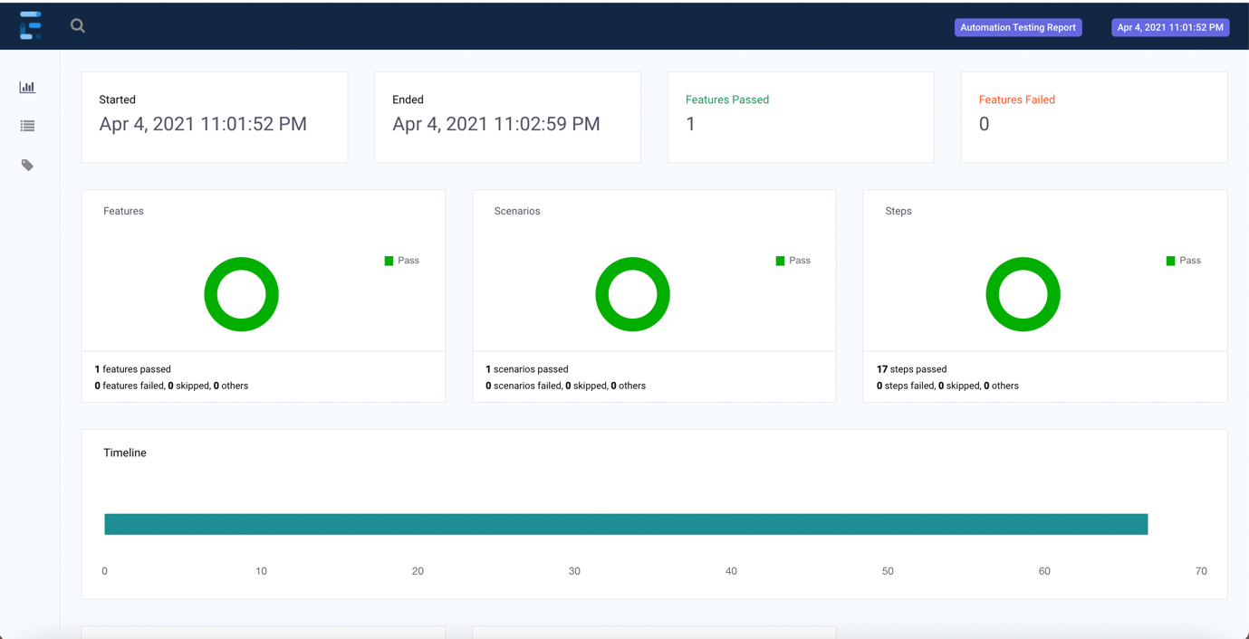

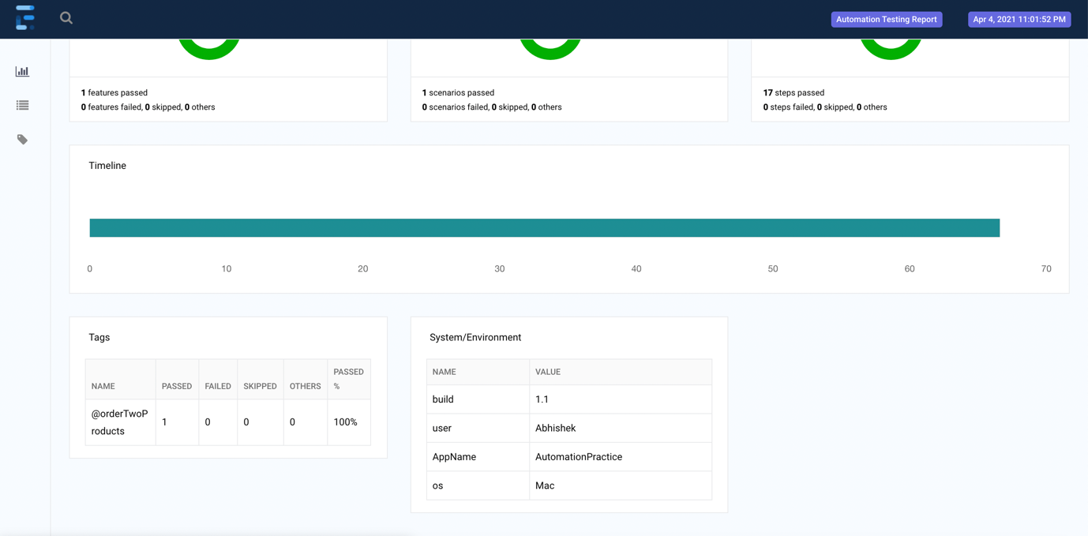

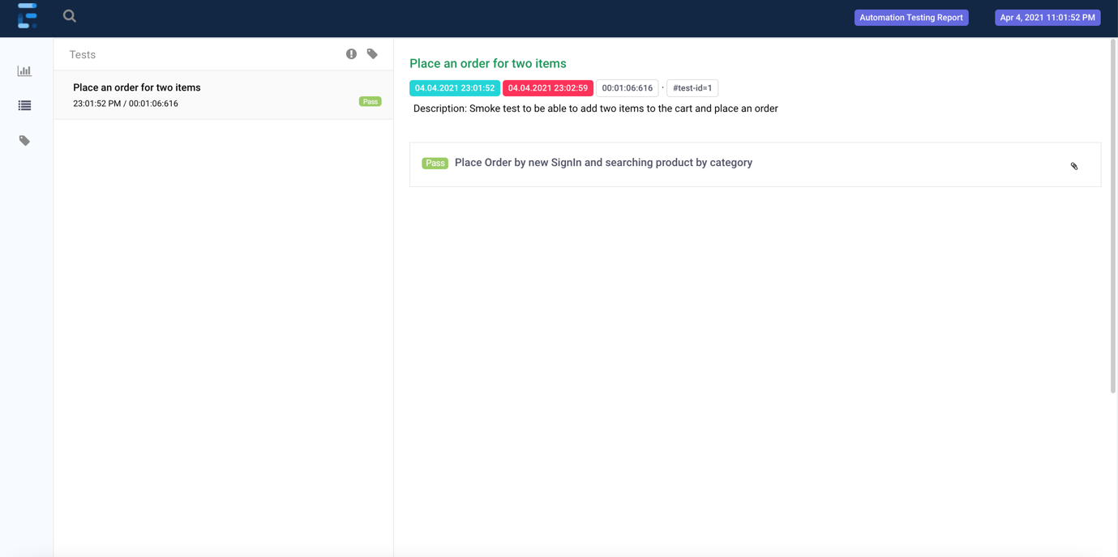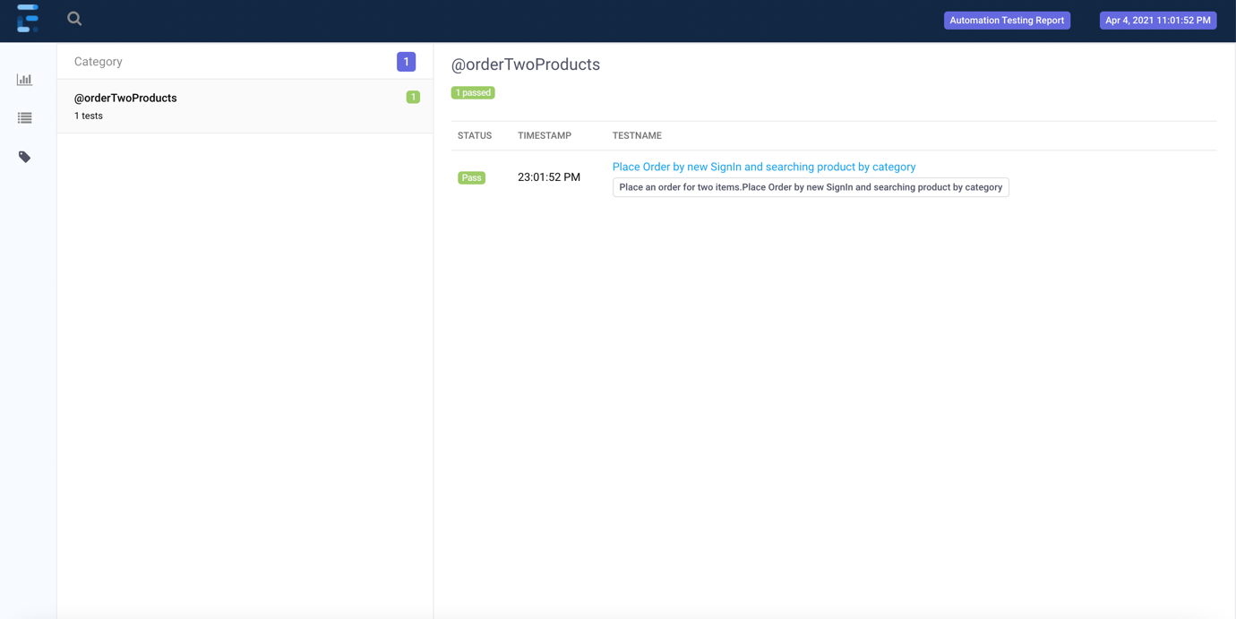

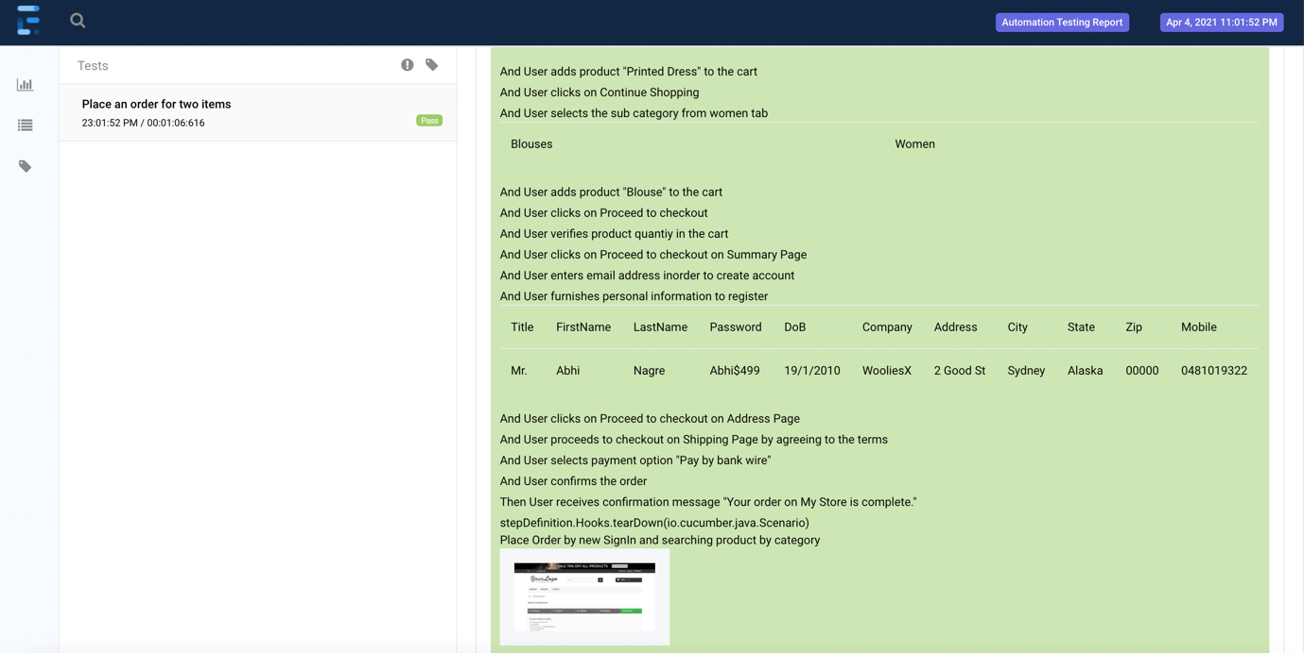

Extent PDF report:

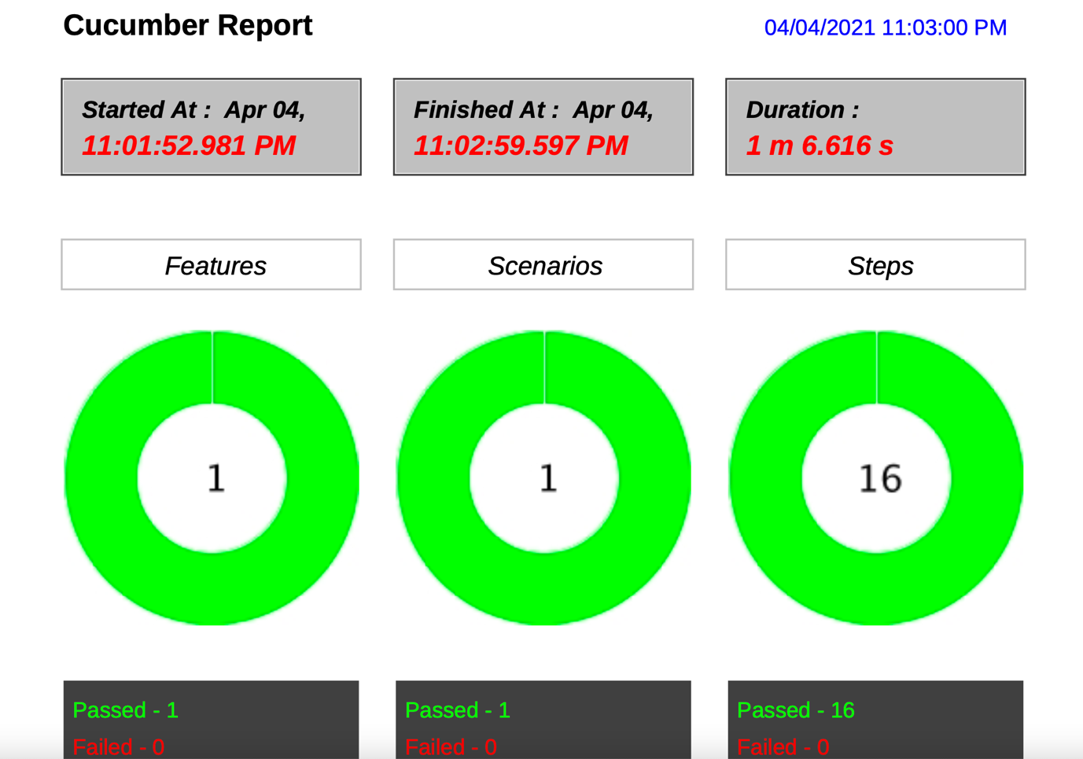

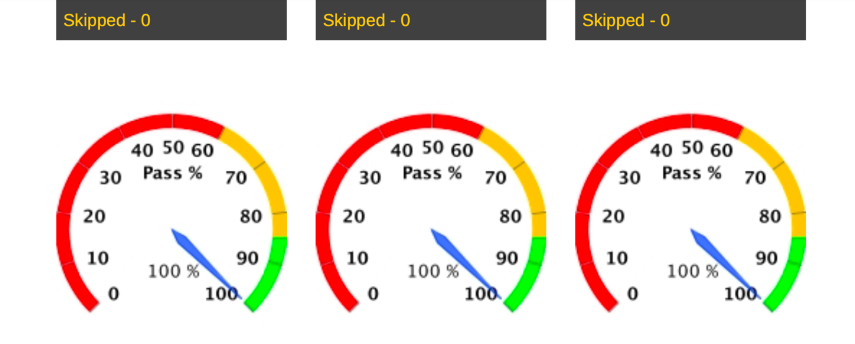

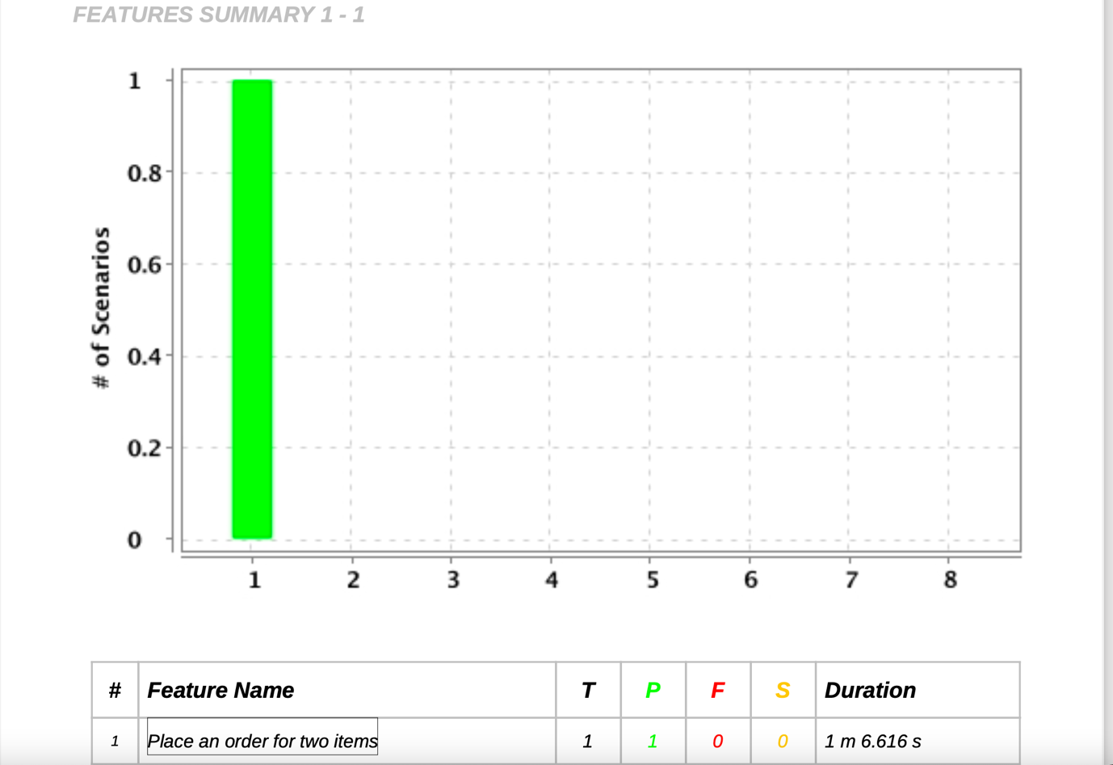

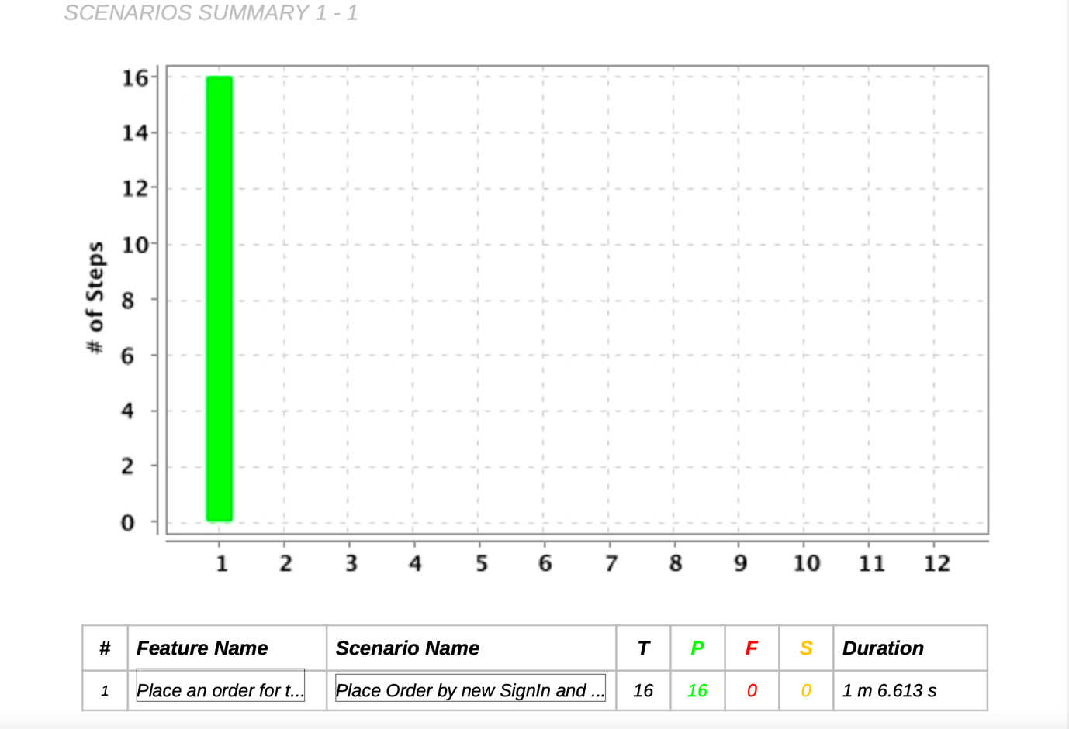

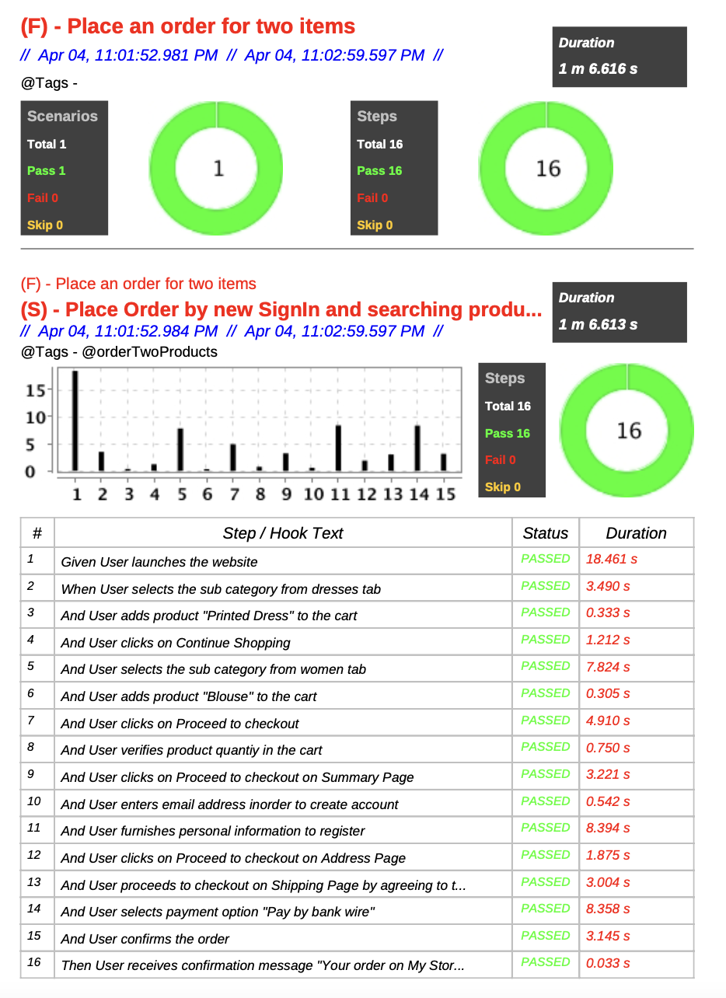

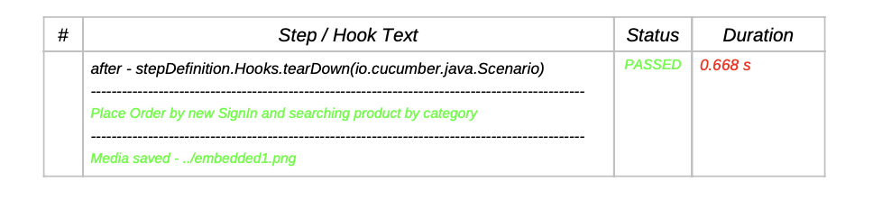

Logs are generated as below in the log folder

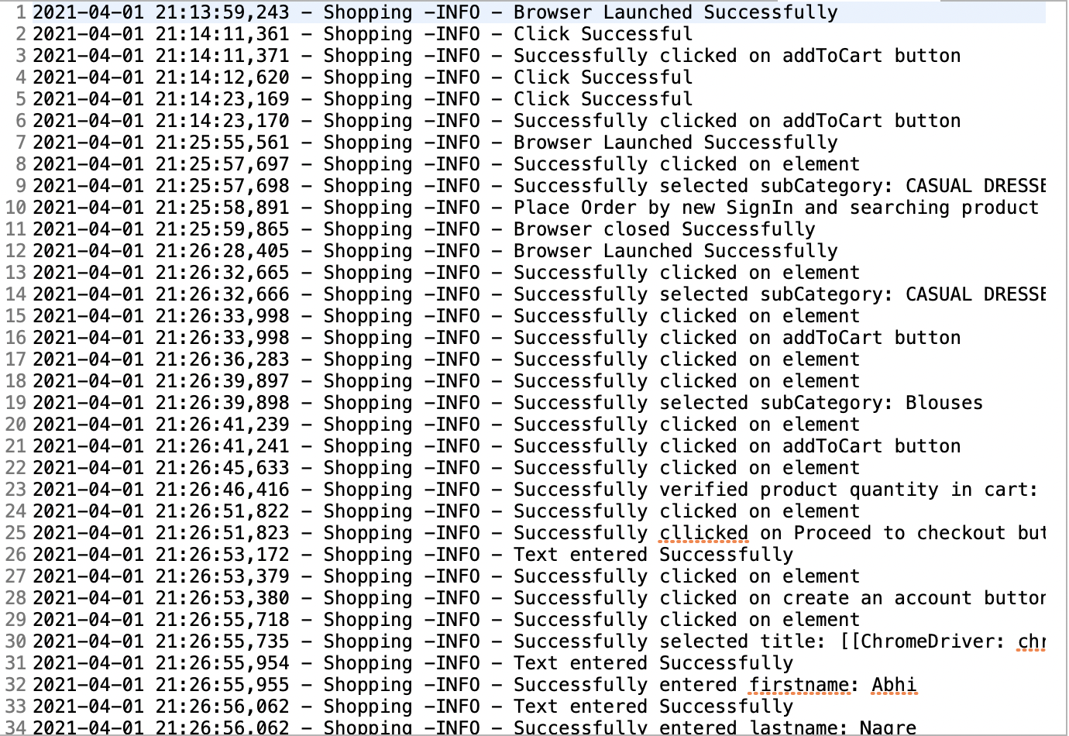

Test results

